ALA -1: Debugging Detective
Description: - Students will be provided with a Python program that contains deliberate syntax and logical errors. The task is to identify and fix all errors so that the program runs successfully and produces the correct output. After completing and verifying the corrected Python code, students must upload all completed tasks to their GitHub repository. Once uploaded, students are required to copy the GitHub repository link and submit that link on the GMIU web portal as proof of completion.This activity helps students develop debugging skills, improve their understanding of common Python errors, and gain experience using GitHub for code management and submission.

ERROR CODE: -
print("Movie Rating")

movies = ["A", "B", "C"]
ratings = []

for i in range(3):
rate = float(input("Enter rating: "))
ratings.append(rate)

avg = sum(ratings) / 3

if avg > 4:
print("Excellent")
else:
print("Average")

print("Average Rating:", avg)

for i in range(2):
print("Done")

print("End")

SOLUTION CODE: -
print("Movie Rating")

movies = ["A", "B", "C"]
ratings = []

for i in range(3):
rate = float(input("Enter rating: "))
ratings.append(rate)

avg = sum(ratings) / 3

if avg > 4:
print("Excellent")
else:
print("Average")

print("Average Rating:", avg)

for i in range(2):
print("Done")

print("End")

No. | Error in Original Code | Type of Error | Correction
1 | for i in range(3) | Missing colon : | for i in range(3):
2 | if avg > 4 | Missing colon : | if avg > 4:
3 | else | Missing colon : | else:
4 | for i in range(2) | Missing colon : | for i in range(2):
5 | No indentation inside loops and if/else | Indentation Error | Indent statements inside blocks
6 | rate = input("Enter rating: ") | Data type error (string instead of number) | rate = float(input("Enter rating: "))
7 | print("Average Rating:", Avg) | Case-sensitive variable error | print("Average Rating:", avg)

OUTPUT: -

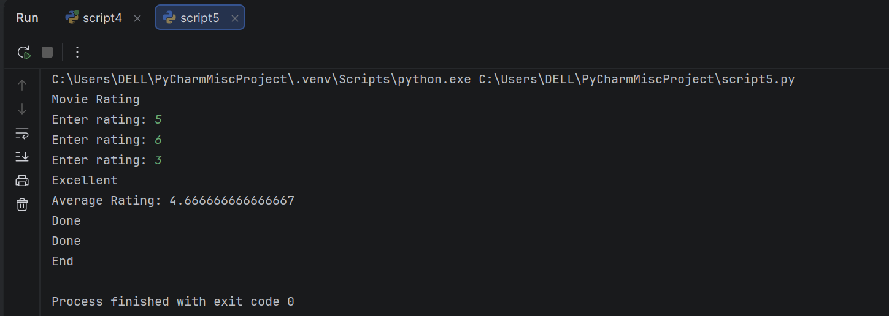

STEPS TO SOLVE THE CODE :-
Looking at your code, I can see several syntax errors. Here are the steps to fix them:

## Step 1: Add Missing Colons
Add colons at the end of these statements:
- `for i in range(3):`
- `if avg > 4:`
- `else:`
- `for i in range(2):`

## Step 2: Fix Indentation
Python relies on proper indentation. Fix the indentation as follows:
```python
print("Movie Rating")
movies = ["A","B","C"]
ratings = []
for i in range(3):
rate = input("Enter rating: ")
ratings.append(rate)
avg = sum(ratings) / 3
if avg > 4:
print("Excellent")
else:
print("Average")
print("Average Rating:", avg)
for i in range(2):
print("Done")
print("End")
```

## Step 3: Fix Variable Name Case Sensitivity
Change `Avg` to `avg` (lowercase) to match the variable name used earlier:
```python
print("Average Rating:", avg)
```

## Step 4: Convert String Inputs to Numbers
The `input()` function returns strings, but `sum()` needs numbers. Convert the ratings to integers or floats:
```python
rate = int(input("Enter rating: "))
# OR
rate = float(input("Enter rating: "))
```

## Complete Corrected Code:
```python
print("Movie Rating")
movies = ["A","B","C"]
ratings = []
for i in range(3):
rate = int(input("Enter rating: "))
ratings.append(rate)
avg = sum(ratings) / 3
if avg > 4:
print("Excellent")
else:
print("Average")
print("Average Rating:", avg)
for i in range(2):
print("Done")
print("End")
```

## Summary of Errors Fixed:
1. Missing colons after loop and conditional statements
2. Incorrect indentation
3. Case sensitivity issue with `Avg` vs `avg`
4. String inputs not converted to numbers for mathematical operations

